**SPADE**Z **SOLUTIONS PVT Ltd.**

SPADEZ

#### CRM Dashboard Enhancement – Eternity Logistics

Contents

Revision History 2

Control of Circulation 2

Communication Details 2

Communication Details Client 2

Executive summary 3

Scope of work 3

SCREEN 1: My Dashboard 3

2. Carrier Dashboard 4

Suggestion 6

3. Customer Dashboard 6

4. Dispatcher Dashboard 7

5. Load Dashboard 9

6. Sales Reps Dashboard 9

Proposed offer 10

Assumptions 11

Pricing & Service 11

Part A 11

Suggestions and approach, Timeline and Milestones 11

# Revision History

|  |  |  |  |
| --- | --- | --- | --- |
| Version No | Effective Date | Author | Summary of Changes |
|  |  |  |  |
|  |  |  |  |

# Control of Circulation

|  |  |  |
| --- | --- | --- |
| Copy No. | Copy Holder (Name, Designation) | Format |
| 1 | Mr. Sajeel Ghai (Co-Founder at Eternity Logistics) | Electronic |
|  |  |  |

# Communication Details

|  |  |  |  |  |
| --- | --- | --- | --- | --- |
| Sr. | Name | Skype | Mobile | Email |
| 1 | Mahesh Sharma |  |  | [sharmamahesh2324@gmail.com](mailto:sharmamahesh2324@gmail.com) |
|  |  |  |  |  |

# Communication Details Client

|  |  |  |  |  |
| --- | --- | --- | --- | --- |
| Sr. | Name | Skype | Mobile | Email |
| 1 | Mr. Sajeel Ghai |  |  | sajeel@eternitylogistics.co |
|  |  |  |  |  |

# Executive summary

Eternity Logistics is looking for the development team to enhance the CRM Dashboard. Eternity Logistics has shared 9 screens of existing ERP Logistic solution, out of which 5 screens are of different dashboards i.e. Carrier Dashboard, Customers Dashboard, Dispatcher Dashboard, Load Dashboard, and Sales Reps Dashboard.

Eternity Logistics developed the basic CRM application and looking to enhance its features with the help of development team. Currently application is hosted on Azure Server.

# Scope of work

Eternity Logistics define the high level requirements in form of presentation. Based on this, Spadez will explore it for the real implementation of requirements and will ask the queries to clarify wherever needed.

## SCREEN 1: My Dashboard

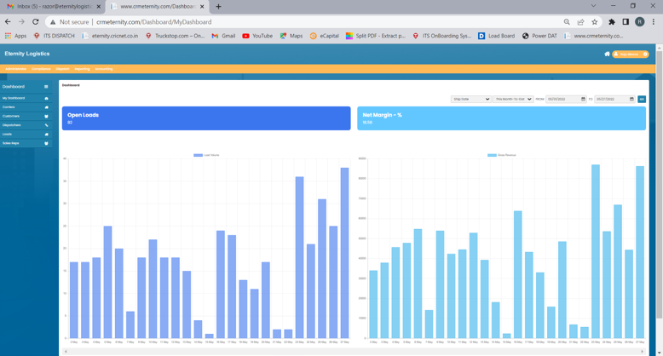

* We can show **4** graphical data of Open Leads and Net Margin % in one screen instead of 2
* We can add no of leads received on each day at top of each column
* We can have leads info of each day as a Tooltip of each plot as shown below

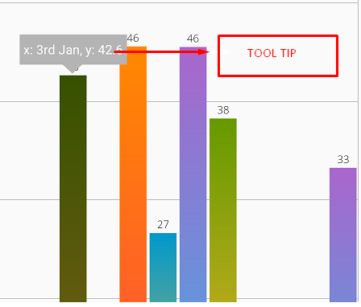

## 2. Carrier Dashboard

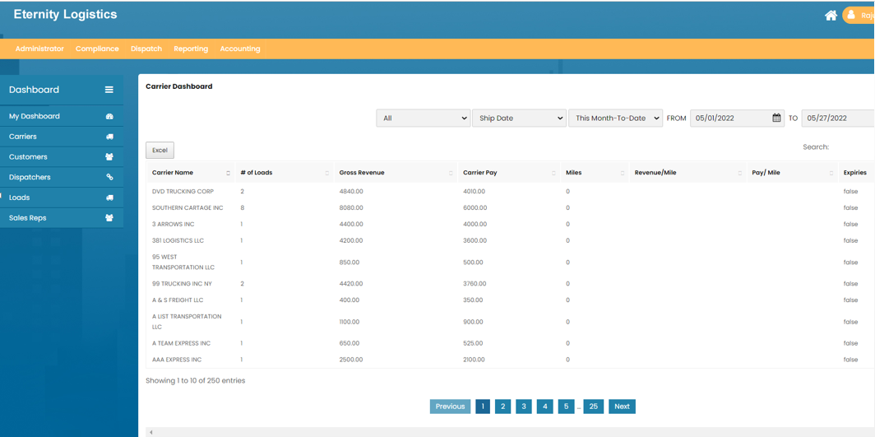

**Business Logic:** < Eternity Logistics can provide the information, or provide the DB and code so that Spadez team can anayse and submit the understating for confirmation >

**Database & Relation:** <Please provide the Database copy, so Spadez can explore >

**Improvements:**

* Rename the column “Expiries” to “Is Expire”
* In Expiries column, please use Yes or No instead of true/false.
* Instead of excel button, we can mention Export dropdown (Print/Excel/CSV/PDF) currently we can keep only option Excel but this will opportunity to add more option.

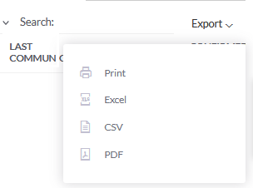

* We can show total Carriers, No of Loads, Total Revenue generated during the time period selected, Total payment given to Carrier, Miles in Dashboard

Gradient effect on header.



* Grid should be eye catchy and colors should highlight the fields.

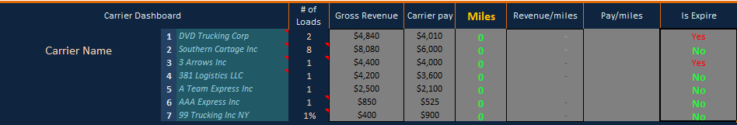

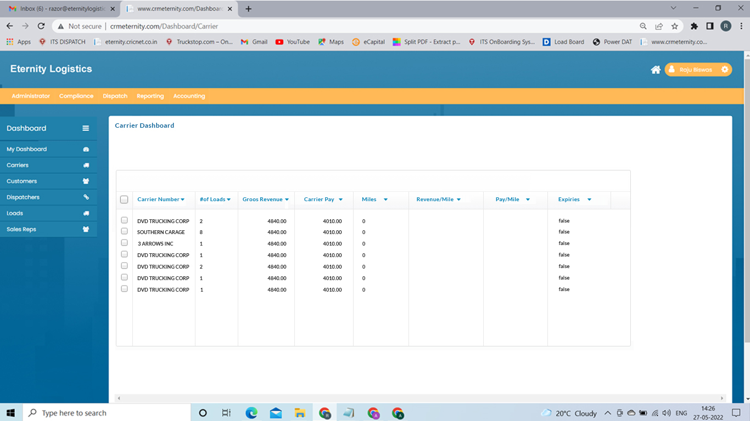

Functional Change

On Clicking the Carrier Name, we can redirect to pop up window OR webpage having information associated with Carrier in details

Suggestion,

We should define the check list to overcome the teething issue for example below one which we found in dashboard grid.

* We should add default Sorting in each grid, and later on user can sort it by columns.
* The number shown in number of loads should be on left side.
* Currency should be formatted and have currency i.e. dollar $ sign, Not like the decimal numbers.
* Can we use color on carrier pay OR Gross Revenue to have idea regarding which carrier is generating more business or which carrier is getting heavily paid

## 3. Customer Dashboard

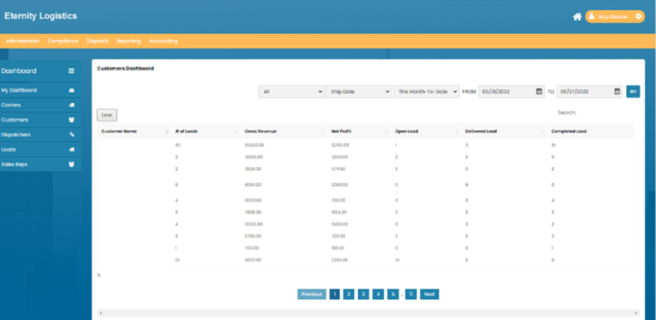

**Business Logic:** < Eternity Logistics can provide the information, or provide the DB and code so that Spadez team can anayse and submit the understating for confirmation >

**Database & Relation:** <Please provide the Database copy, so Spadez can explore >

**Improvements:**

* Instead of excel button, we can mention Export dropdown (Print/Excel/CSV/PDF)
* We can have pop up when we click open/delivered/completed leads having information of person to whom lead was assigned and who has completed
* We can have column of showing lead in progress
* We can show $ in currency received as gross revenue and net profit in %
* We can have sorting in each grid

## 4. Dispatcher Dashboard

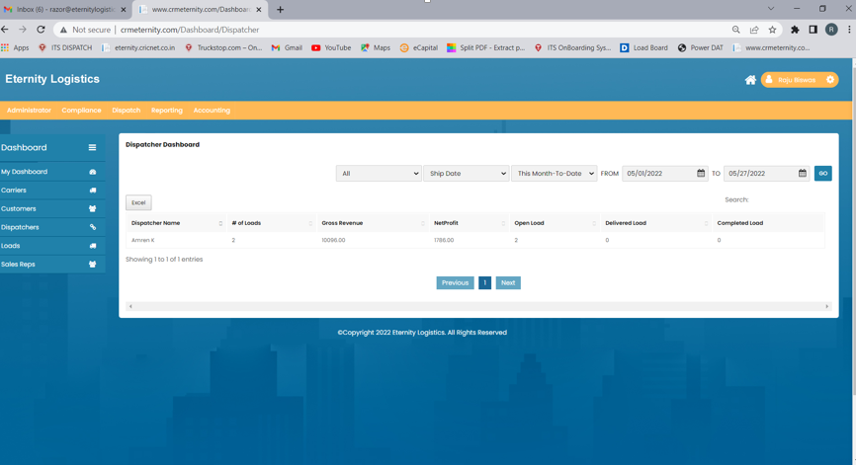

**Business Logic:** < Eternity Logistics can provide the information, or provide the DB and code so that Spadez team can anayse and submit the understating for confirmation >

**Database & Relation:** <Please provide the Database copy, so Spadez can explore >

**Improvements:**

* Instead of excel button, we can mention Export dropdown (Print/Excel/CSV/PDF)
* We can have pop up when we open/delivered/completed leads having information of person to whom lead was assigned and who has completed
* On Clicking the dispatcher name, we can have details associated with it in pop up window or webpage
* We can show $ in currency received as gross revenue and net profit in %

## 5. Load Dashboard

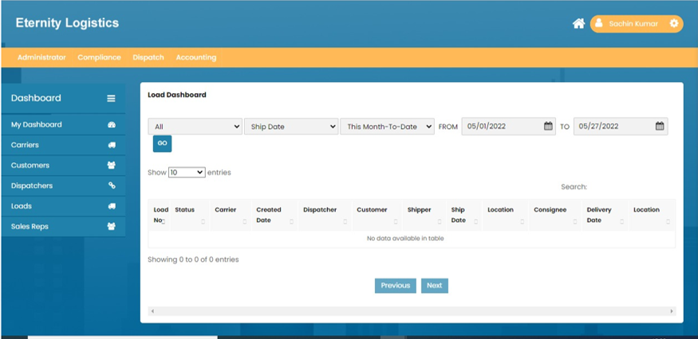

**Business Logic:** < Eternity Logistics can provide the information, or provide the DB and code so that Spadez team can anayse and submit the understating for confirmation >

**Database & Relation:** <Please provide the Database copy, so Spadez can explore >

**Improvements:**

* On Clicking the Load number, we can have details associated with it in pop up window or webpage
* We can specify location whether it is of Shipment or delivery port instead of only location
* We can show time of shipment and delivery if needed

## 6. Sales Reps Dashboard

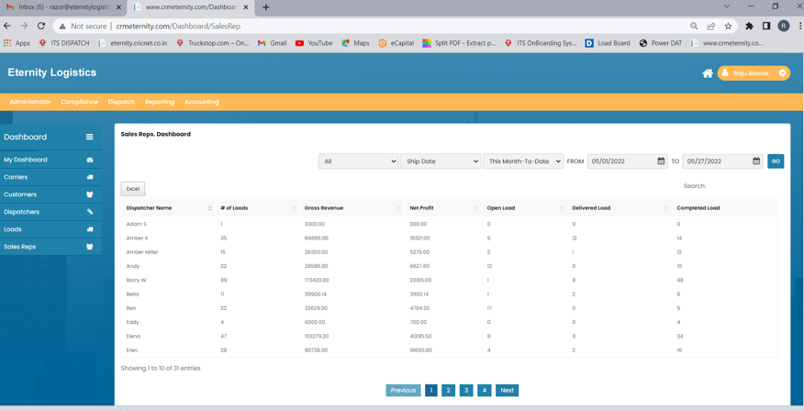

**Business Logic:** < Eternity Logistics can provide the information, or provide the DB and code so that Spadez team can anayse and submit the understating for confirmation >

**Database & Relation:** <Please provide the Database copy, so Spadez can explore >

**Improvements:**

* On Clicking the Dispatcher name, we can have details associated with him in pop up window or webpage
* We can show $ in currency received as gross revenue and net profit in %
* We can show total number of lead open/delivered/completed at grid
* We can show total number of leads in progress
* Instead of excel button, we can mention Export dropdown (Print/Excel/CSV/PDF)
* We can have pop up with details on clicking open/delivered/completed leads

# Proposed offer

Spadez need to send proposal to evaluate the screens shared in presentation to improve the dashboards shared as snapshots and not the implementation of the theme on the whole application.

Requirement before Estimation

Note: For estimation and cost of the screens, we need a Database copy OR ER diagram to understand the current layout and design of the database schema.

### Assumptions

1. Do Eternity Logistics need to implement new theme for dashboard implementation?
2. Please provide more information related to dashboard screens as shared in PPT as we can tweak the GUI for user experience but not helping as functionality.

**Spadez recommendation**: The following data should be displayed on the dashboard.

Like todays Load, Overdue bills, overdue payments.

Eternity Logistics can provide information which they want to show in dashboard to make business decision or focus items of the day.

# Pricing & Service

## Part A

Proposed fixed price for CRM Dashboard improvements and implementation

|  |  |  |  |  |  |
| --- | --- | --- | --- | --- | --- |
| Sr No | Description | Hour daily | Pricing Model | Week | Total amount in USD |
| 1 |  | -- | Fixed Price |  |  |

# Suggestions and approach, Timeline and Milestones